

Data Technician

Name: Kieran Salaria
Course Date: January 5th 2026
Table of contents
Day 1: Task 1 3
Day 1: Task 2 5
Day 1: Task 3 6
Day 1: Task 4 7
Day 2: Task 1 9
Day 2: Task 2 10
Day 2: Task 3 13
Day 3: Task 1 13
Day 3: Task 2: Skillable 14
Day 3: Task 3: Skillable 17
Day 4: Task 1: MS Fabric using Just IT 19
Day 4: Task 2: Skillable 20
Day 4: Task 3 (Optional) 21
1. Scenario Background 21
2. Data Laws and Regulations 21
3. Azure Service Recommendations 21
4. Data Types and Data Modelling 21
5. Data Storage Formats and Structures in Azure 22
6. Additional Considerations 22
Submission Guidelines: 22
Course Notes 25
Additional Information 25

Day 1: Task 1

Please research and complete the below questions relating to key concepts of cloud.

Be prepared to discuss the below in the group following this task.

What can cloud computing do for us in the real-world? | Cloud computing can be found in various aspects of everyday life. For example, we can use it to store files (images, documents and video) and share them easily across different devices and platforms.
How can it benefit a business? | With cloud computing, businesses are able to cut down on the costs of maintaining physical data servers when managing their documentation and data.  Additionally, there is the additional potential of remote working opportunities with real-time file sharing between employees and devices that allows for teamwork and communication to be more prevalent in the process.
What’s the alternative to cloud computing? | An alternative to cloud computing would be Edge Computing. Instead of relying on a cloud server to store and process data, it involves storing the data close to or directly on the technology/machinery that consumes and generates the data directly.  This would be most useful in the event that data processing is needed instantly.
What cloud providers can we use, what are their features and functions? | There are three main cloud providers.  Amazon Web Services (AWS):  A large cloud hosting provider. They provide a vast range of cloud-based products such as computing, storage, databases, analytics and developer tools. As it can be easily scaled to accommodate the needs of a business, it can be used for any sized business to quickly manage their data and respond to business requirements without an overhaul of costs.  Microsoft Azure:  A cloud computing platform; Azure uses Microsoft-managed data centres to provide businesses with a cloud-based management service for their applications. Azure in particular has hybrid options that may work for businesses that are looking to get into cloud computing but are precautious with any security risks.  Google Cloud Platform:  GCP is Google’s equivalent for a cloud computing service. It provides virtual machinery, cloud storage and data tools to businesses to support their work management. With numerous tools as part of the Google Workspace such as Gmail, Drive and Docs, people are able to collaborate on projects easily which provides remote working opportunities.

Day 1: Task 2

Pricing Calculator: In this exercise, you use the Pricing calculator to estimate the cost of running a basic web application on Azure.
Exercise - Estimate workload costs by using the Pricing calculator - Training | Microsoft Learn

Cost of a basic web application | 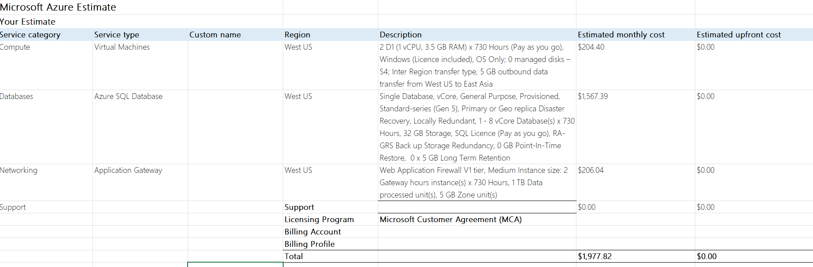  Taken from the Microsoft Excel export of my findings.  I could not find the specified D2V3 from the exercise for the Virtual Machines instance series dropdown, so I substituted it for the D-series option.

Day 1: Task 3

Please research the below cloud offerings, explain what they are and examples of use cases.

Cloud Offerings | Explain what it is | When / how might you use this service in the real-world?
IaaS (Infrastructure as a service) | This is the provision of a computing infrastructure, where businesses can purchase the necessary resources on demand without the need to buy any hardware. It can be easily scaled to suit the needs of any business. The cloud provider manages all of the hardware and the networking. | IaaS can be used to create testing environments and virtual machines that can be used to test applications.  It is also used for website hosting as it provides the resources capable of dealing with the traffic websites will generate.
PaaS (Platform as a service) | These provide a platform for software creation over the internet. With a PaaS, users do not have to worry about the storage or software updates necessary; it can be easily customised by businesses to streamline their workflows. | PaaS allows developers to focus their attention on development applications without having to deal with the actual infrastructure, which makes It a good tool for web application development.
SaaS (Software as a service) | These are cloud application services that make use of the internet to deliver applications to users, without the need for an IT staff to deliver the software manually onto each computer. These can save time on installing, managing and upgrading software due to being managed from a central location hosted on a remote server. | As the SaaS model involves a functional application fully managed by a third party, these will find use in project management as businesses outline their projects and responsibilities.

Day 1: Task 4

Please research the below terms and explain what they are, when they would be appropriate and a real-world example of where it could be implemented (i.e. what type of organisation).

Public Cloud | This model is offered as a virtual resource freely available on the internet and are easily scaled to suit a business or individual’s needs. The service is managed by a third-party provider.  They also operate on a pay-as-you-go model, which would make them ideal for smaller businesses on tighter budgets to manage their data requirements.
Private Cloud | This model by contrast is an environment exclusive to a single business. It will be significantly tailored to the needs of the company as they can make their own adjustments.  A private cloud can be seen as being more secure due to how exclusive it is to the business. It is ideal for managing more confidential data that a business may not feel can be shared on a more accessible resource.
Hybrid Cloud | A hybrid model combines the private and public computing environment models to offer a mix of enhanced control of sensitive data with potential for flexibility and scalability.  An example of its usage would be in a financial sector, as they would need to deal to sensitive financial records while also providing it them with the opportunity to develop more optimal customer experiences.
Community Cloud | A community cloud unites multiple organisations that share common needs; through a community cloud, these organisations can access a shared pool of data and resources that adhere to a shared understanding of policies and protocols.  This kind of model would be most prevalent in the healthcare sector, where medical information can be easily shared across a shared model so that it can be retrieved as and when it is required.

Day 2: Task 1
You are a Cloud Consultant hired by a client. You will identify the most suitable cloud service model for a client requiring control over infrastructure, estimate potential cloud costs, and explain the benefits of cloud adoption.
🏭 Client – "DataCore Enterprises"
- A large enterprise wants to move its internal database servers to the cloud.
- They already have IT staff.
- They want full control over operating systems and storage configuration.
Questions for you:
- Which service model suits them? (IaaS, PaaS, Saas)
- How can they estimate the cost of using cloud services?
- What are the possible benefits of using cloud services?
- Bonus: What might be potential risks?
Answer
The model that would most suited for DataCore Enterprises would be the infrastructure as a service cloud model. This is because the company is looking to have as much control as possible over their operating system and storage, and can have its existing team manage all of the virtual resources after being provided with the hardware.
To estimate the costs, they can use a pricing calculator, which can be found when looking into cloud service providers (for example, Azure has a pricing calculator that allows users to determine the cost according to their specifications). These will provide the company with an estimate based on their needs.
The potential benefits of using a cloud service would include:
- The company only having to pay for what they are using.
- Teams in the company are able to easily collaborate in real-time no matter where they are.
- Having access to high-performance computing that allows for faster data processing and analysis.
Potential risks of using a cloud service include the dependency on an internet connection, migrating existing data onto the cloud service, and being susceptible to any changes in pricing that the company may not be expecting.

Day 2: Task 2

Describe, with examples, the three major areas that the Computer Misuse Act deals with.

Area | Description | Example
Unauthorized access to computer material. | Getting access to a computer or data materials without being permitted. | Hacking into a company’s servers to gain access.
Unauthorised access with the intent to commit further offences. | Not only gaining access to materials without being permitted, but also using the data found to commit a further offence. | Using a company’s data to blackmail them, effectively keeping it hostage.
Unauthorised modification of computer material. | Intending to change – or even destroy – existing software or data. | An unauthorised addition of a password to data file.

The computer misuse act 1990 is an act where an individual can be criminalised because of computer related offense. Describe three extra powers that the Police and Justice Act 2006 (Computer Misuse) has added.

Description
An increased penalty for unauthorised access, which includes a higher maximum penalty of two years imprisonment.
The tools used to intentionally commit cybercrime have been criminalised, making the use or supplying of means to obtain unauthorised access to data an offence in and of itself.
A broader scope of offence to cover other means of harm such as impairing the reliability of data or hindering the access of those who are indeed authorised.

Look at the below website to answer the questions:
https://www.gov.uk/personal-data-my-employer-can-keep-about-me

Write down three items of data which a company can store about an employee.
National Insurance Number
Employment History with the Company/Organisation
Emergency Contact Details

Give three more examples of data that an employer can only store if they first get the employee’s permission.
The race and ethnicity of the employee.
The employee’s biometric information.
The sexual orientation of the employee.

Conduct further research to answer the below questions.

Question | Answer
Provide one example of: Copyright infringement | Using images sourced from a website without permission.
Provide one example of: Plagiarism | Copying text verbatim without any quotation marks.
What are two consequences of copyright infringement and software piracy? | People who commit either of these acts may be subjected to a significant fine, as well as penalties such as being suspended from their work or education.
Give three possible consequences for individuals when using pirated software | Legal consequences.  No warranties on the software.  Increased exposure to viruses and cyberattacks.

Listed below are some laws which we have covered today:

1. Computer Misuse Act 1990
2. Police and Justice Act 2006 (Computer Misuse)
3. Copyright, Designs and Patents Act 1988
4. Copyright (Computer Programs) Regulations 1992
5. The Health and Safety (Display Screen Equipment) Regulations 1992
6. Data Protection Act 2018
7. Consumer Rights Act 2015

Insert a number in the first column of each row to match each of the statements with one of the above Acts.
One of statements is incorrect and not illegal. For this statement, write ‘Not illegal’.

Act number | Clause
3 | With some exceptions, it is illegal to use unlicensed software
7 | Any product, digital or otherwise, must be fit for the purpose it is supplied for.
1 | Unauthorised modification of computer material is illegal
Not illegal. | It is illegal to create or use a hacking tool for penetration testing
6 | Personal data may only be used for specified, explicit purposes
5 | Employers must provide their computer users with adequate health and safety training for any workstation they work at
2 | It is illegal to distribute hacking tools for criminal purposes
3 | It is illegal to distribute an illicit recording
6 | Personal data may not be kept longer than necessary
1 | Gaining unauthorised access to a computer system is illegal
5 | Employers must ensure that employees take regular and adequate breaks from looking at their screens
2 | It is illegal to prevent or hinder access (e.g. by a denial-of-service attack) to any program or data held in any computer
6 | Personal data must be accurate and where necessary kept up to date

Day 2: Task 3

Please complete this activity to the best of your ability. This is an introduction to Azure Cloud Computing. You can skip Exercises as we will complete day later.

Introduction to Cloud Infrastructure: Describe Azure Architecture and Services - Training | Microsoft Learn

Day 3: Task 1

Please complete the below lab (1) ‘Explore Azure SQL Database’ and paste evidence of the completed lab in the box provided.



Completed Lab | 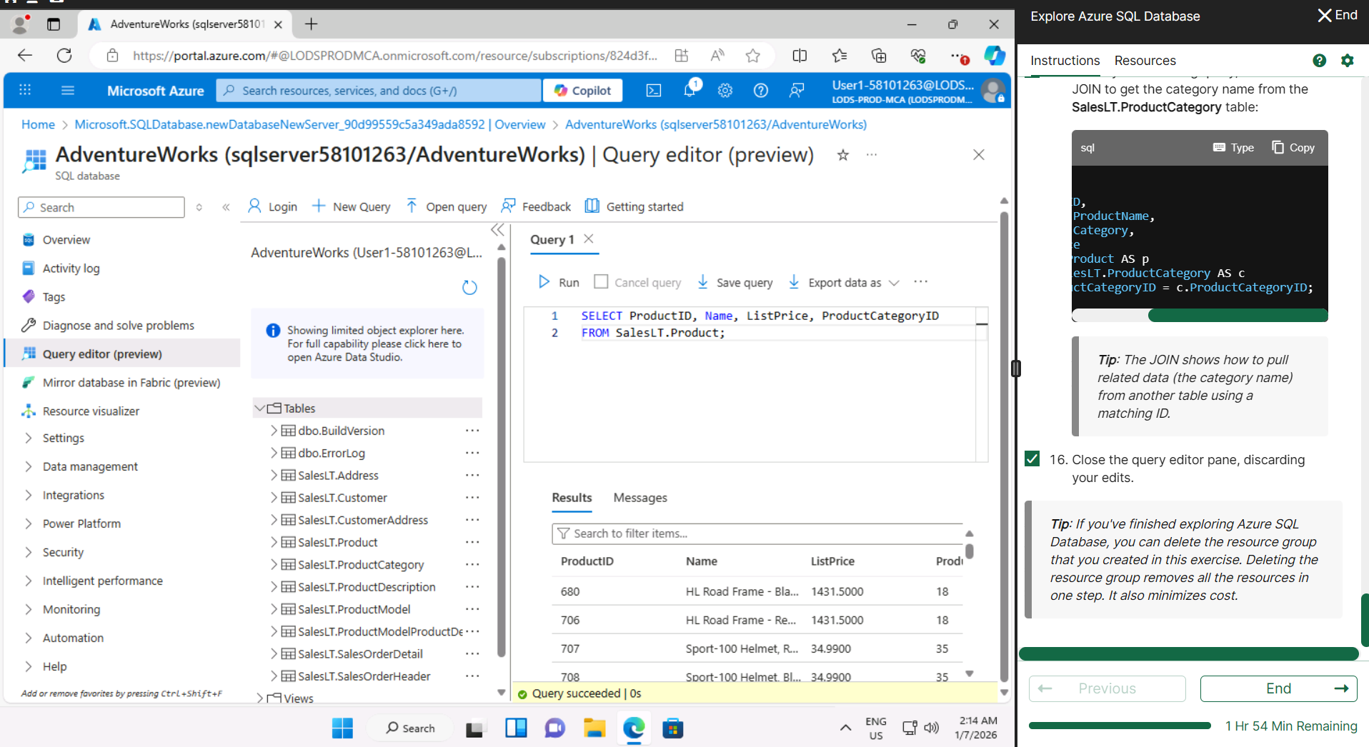

Day 3: Task 2: Skillable
Complete below exercises in lab environment using AdventureWorks DB.
You can view Schema Design here.

LIST PRICE = Is in the product table.
STANDARD COST =

-- 1. Customers with last names starting with 'A'
-- Scenario: The marketing department is preparing a campaign targeting customers whose last names begin with the letter 'A'. They need a list of these customers to personalize outreach messages.

SELECT FirstName, LastName
FROM SalesLT.Customer
WHERE LastName like 'A%';

-- 2. Customers with first name starting with 'A' and last name ending with 'a'
-- Scenario: The CRM team is analyzing customer name patterns for personalization strategies. They're particularly interested in users with a first name starting with 'A' and a last name ending in 'a'.

SELECT FirstName, LastName
FROM SalesLT.Customer
WHERE LastName like '%A' AND FirstName like 'A%'

-- 3. Count of customers with first name starting with 'A' and last name including 'o'
-- Scenario: A data analyst is generating statistics for a name segmentation report and needs to count how many customers meet both criteria: first name starts with 'A' and last name contains the letter 'o'.

SELECT count(CustomerID) as 'Number of Customers'
FROM SalesLT.Customer
WHERE FirstName like 'A%' AND LastName like '%O%';

-- 4. Top 3 black products of size 'S' ordered by list price
-- Scenario: The merchandising team is curating a list of 'Black' colored products in size 'S' for a limited-time promotion. They want to showcase the top 3 most affordable options first.

SELECT TOP 3 Product.Name, Product.Color, ListPrice
FROM SalesLT.Product
WHERE Size = 'S' AND Product.Color = 'Black'
ORDER BY ListPrice ASC;

-- 5. Average standard cost of products
-- Scenario: The finance team is calculating the average standard cost across all products to assess baseline production expenses.

SELECT avg(UnitPrice) as 'Average Unit Cost'
FROM SalesLT.SalesOrderDetail;

-- 6. Difference between average standard cost and average list price
-- Scenario: The pricing strategy team is examining the average markup between the standard cost and the list price to evaluate profitability trends.

select avg(p.listprice) - avg(sod.unitprice) as 'Difference in Pricing'
from [SalesLT].[SalesOrderDetail] sod
join [SalesLT].[Product] p on p.productid = sod.productid;

-- 7. Product with highest profit margin
-- Scenario: Management wants to identify the most profitable product by finding the item with the highest difference between list price and standard cost.

SELECT p.name, avg(p.listprice) - avg(sod.unitprice) as 'Profit Margin'
FROM [SalesLT].[Product] p
JOIN [SalesLT].[SalesOrderDetail] sod on p.productid = sod.productid
GROUP BY p.Name
ORDER BY 'Profit Margin' desc;

-- 8. Number of products per category
-- Scenario: Inventory control needs a summary of how many products exist in each product category to manage stock levels effectively.

SELECT pc.name, count(p.productID) as 'Product Count'
from [SalesLT].[ProductCategory] pc
left join [SalesLT].[Product] p on p.productcategoryid = pc.productcategoryid
GROUP BY pc.name
ORDER BY count(p.productID) desc;

-- 9. Average list price by category
-- Scenario: The product pricing team is reviewing average list prices by category to adjust pricing strategies and identify outliers.

SELECT pc.name, avg(p.listprice) as 'Average List Price'
FROM [SalesLT].[ProductCategory] pc
JOIN [SalesLT].[Product] p on p.productcategoryid = pc.productcategoryid
WHERE 'Average List Price' is not null
GROUP BY pc.name ORDER BY 'Average List Price' desc;
)
-- 10. Orders with customer information
-- Scenario: The operations team needs a comprehensive report of customer orders, including order details and basic customer info, to review sales performance.

SELECT concat(c.firstname, ' ', c.lastname) as 'Customer Name', c.emailaddress as 'Email', c.companyname as 'Company', o.orderdate as 'Order Date'
FROM [SalesLT].[Customer] c
JOIN [SalesLT].[SalesOrderHeader] o on o.customerid = c.customerid;

-- 11. Products priced above average list price
-- Scenario: The sales team wants to identify premium products that are priced above the average list price for highlighting in high-end marketing campaigns.

SELECT p.name, p.listprice
FROM [SalesLT].[Product] p
CROSS JOIN (SELECT AVG(listprice) AS avg_price FROM [SalesLT].[Product]) a
WHERE p.listprice > a.avg_price
ORDER BY p.listprice DESC;

-- 12. Total quantity sold per product
-- Scenario: The business intelligence team is evaluating product performance by analyzing the total quantity sold for each product across all orders.

SELECT p.Name AS ProductName, SUM(sod.OrderQty) AS 'Total Quantity Sold'
FROM SalesLT.Product p
JOIN SalesLT.SalesOrderDetail sod ON p.ProductID = sod.ProductID
GROUP BY p.Name
ORDER BY 'Total Quantity Sold' DESC;

-- 13. Total sales per customer
-- Scenario: The customer success team wants to calculate the total value of orders placed by each customer to identify high-value clients for loyalty programs.

SELECT concat(c.firstname, ' ', c.lastname) as 'Customer Name', count(soh.customerid) as 'Number of Transactions'
FROM [SalesLT].[Customer] c
JOIN [SalesLT].[SalesOrderHeader] soh on soh.customerid = c.customerid
GROUP BY concat(c.firstname, ' ', c.lastname)
ORDER BY 'Number of Transactions' desc;

Day 3: Task 3: Skillable

Please complete the below lab (4) ‘Explore non-relational data in Azure’ and paste evidence of the completed lab in the box provided.



Completed Lab | 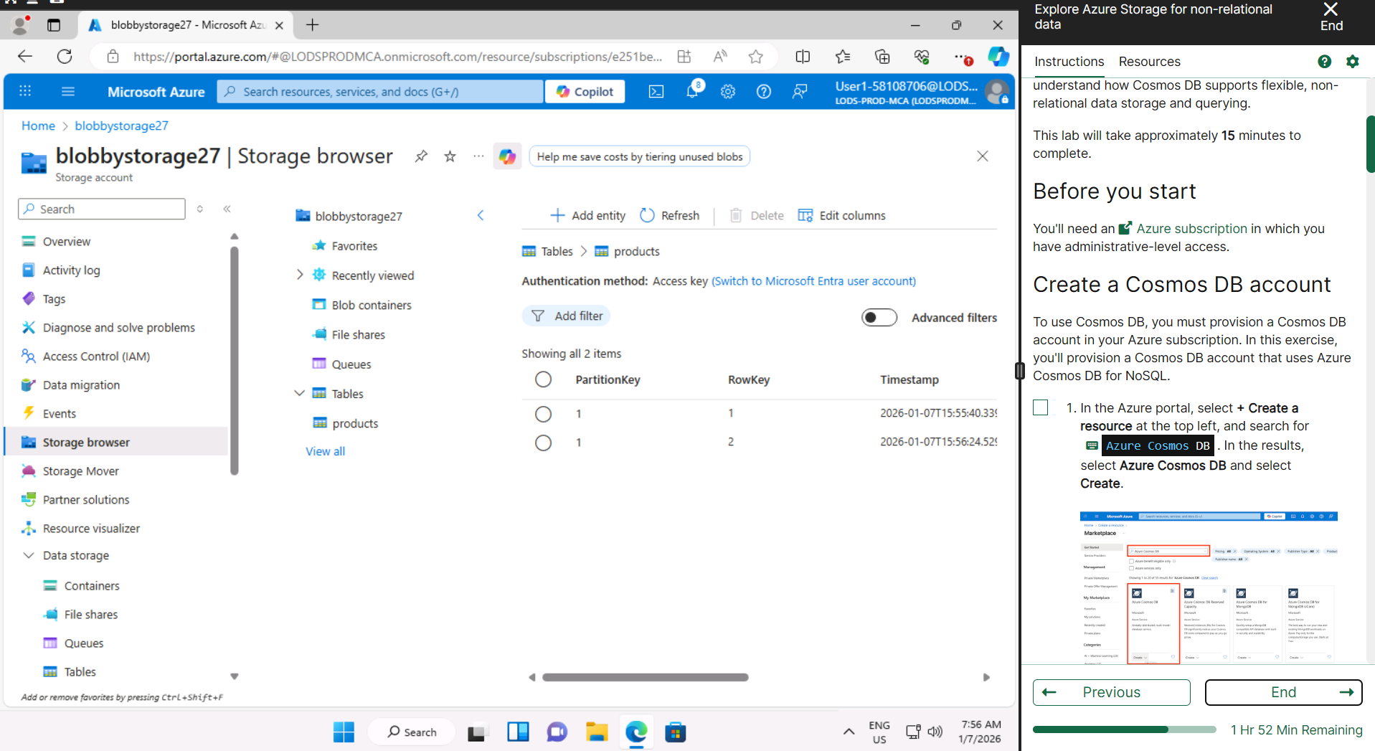  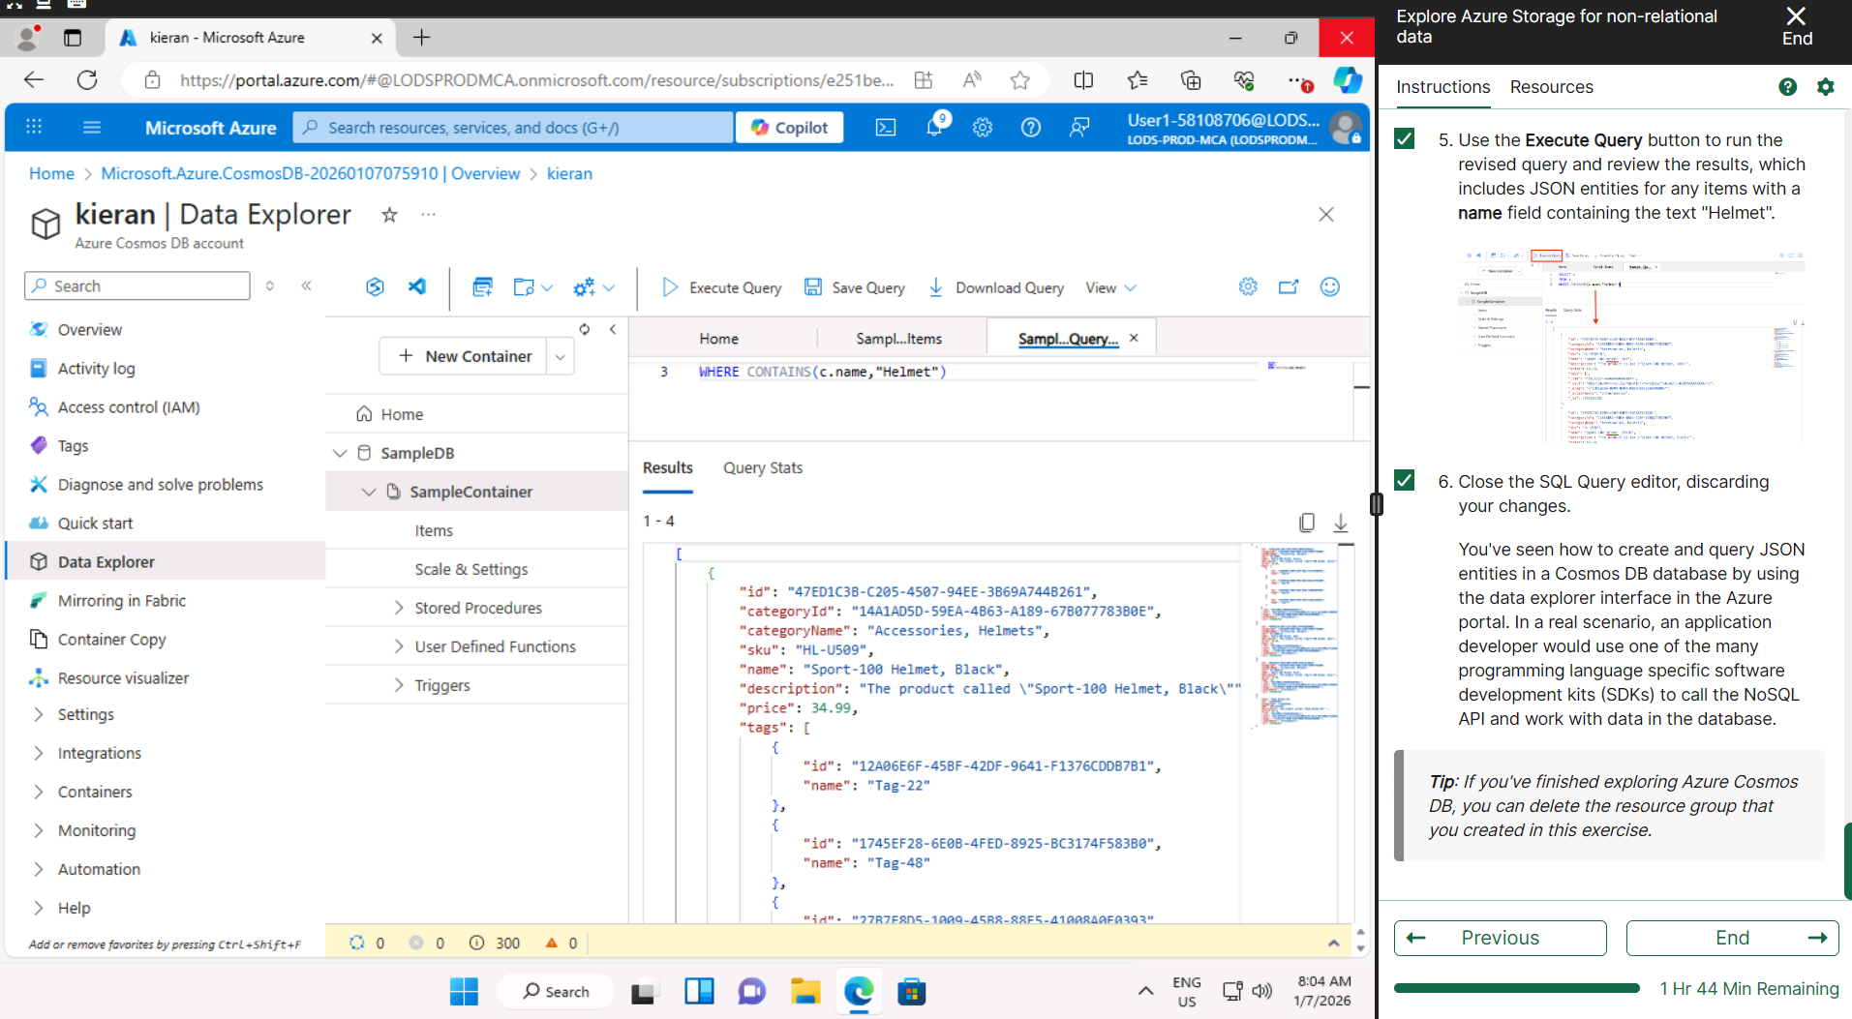

Day 4: Task 1: MS Fabric using Just IT
Please follow the link below to complete the lab using your Just IT account in MS Fabric.
There are 3 modules to complete.

Data Factory end-to-end tutorial introduction and architecture - Microsoft Fabric | Microsoft Learn

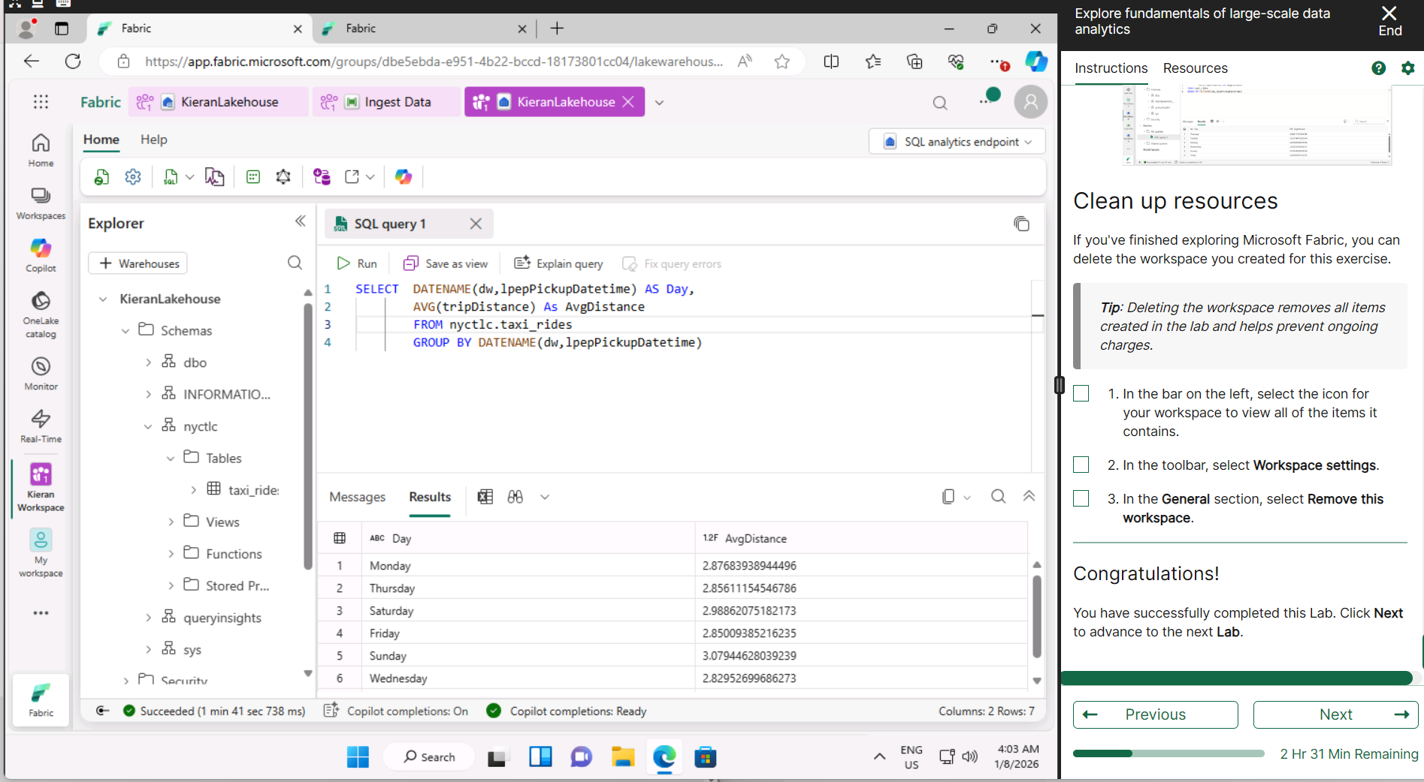

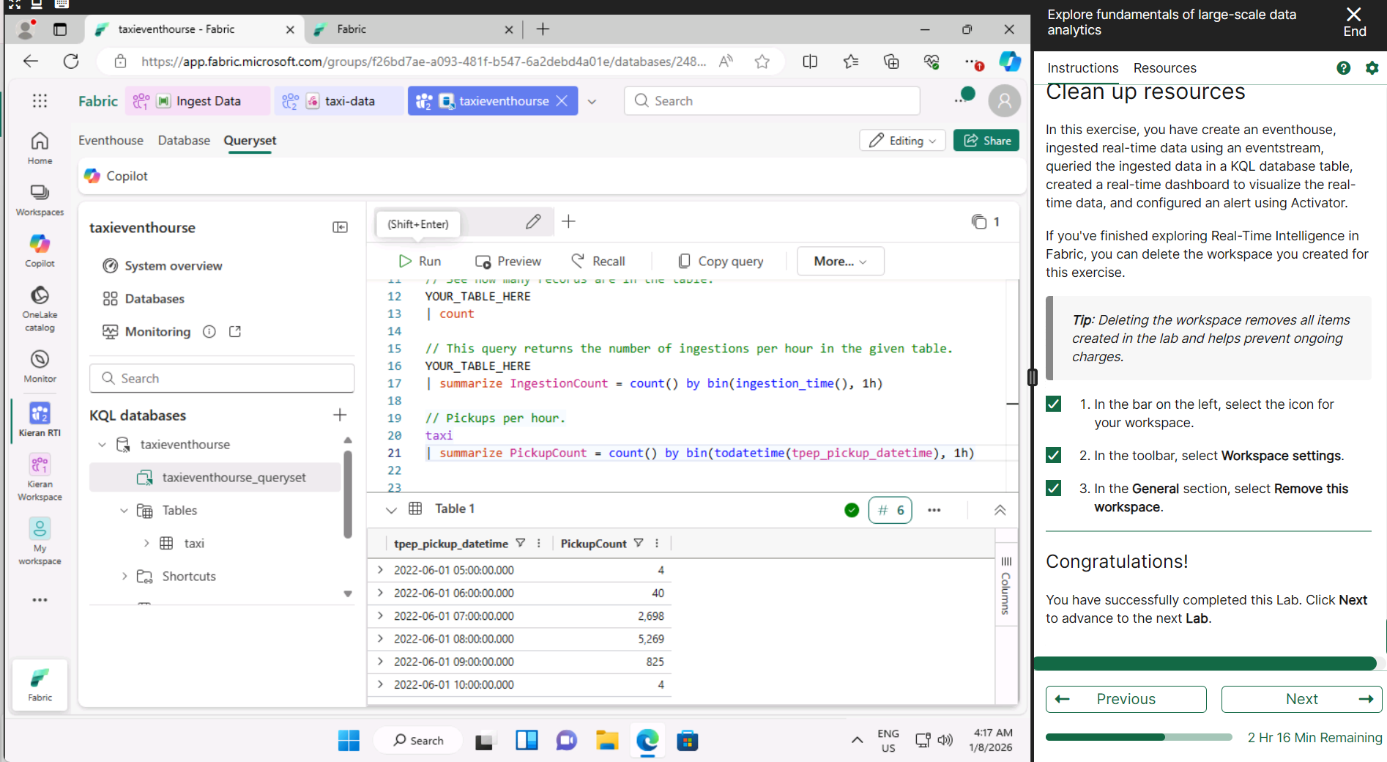
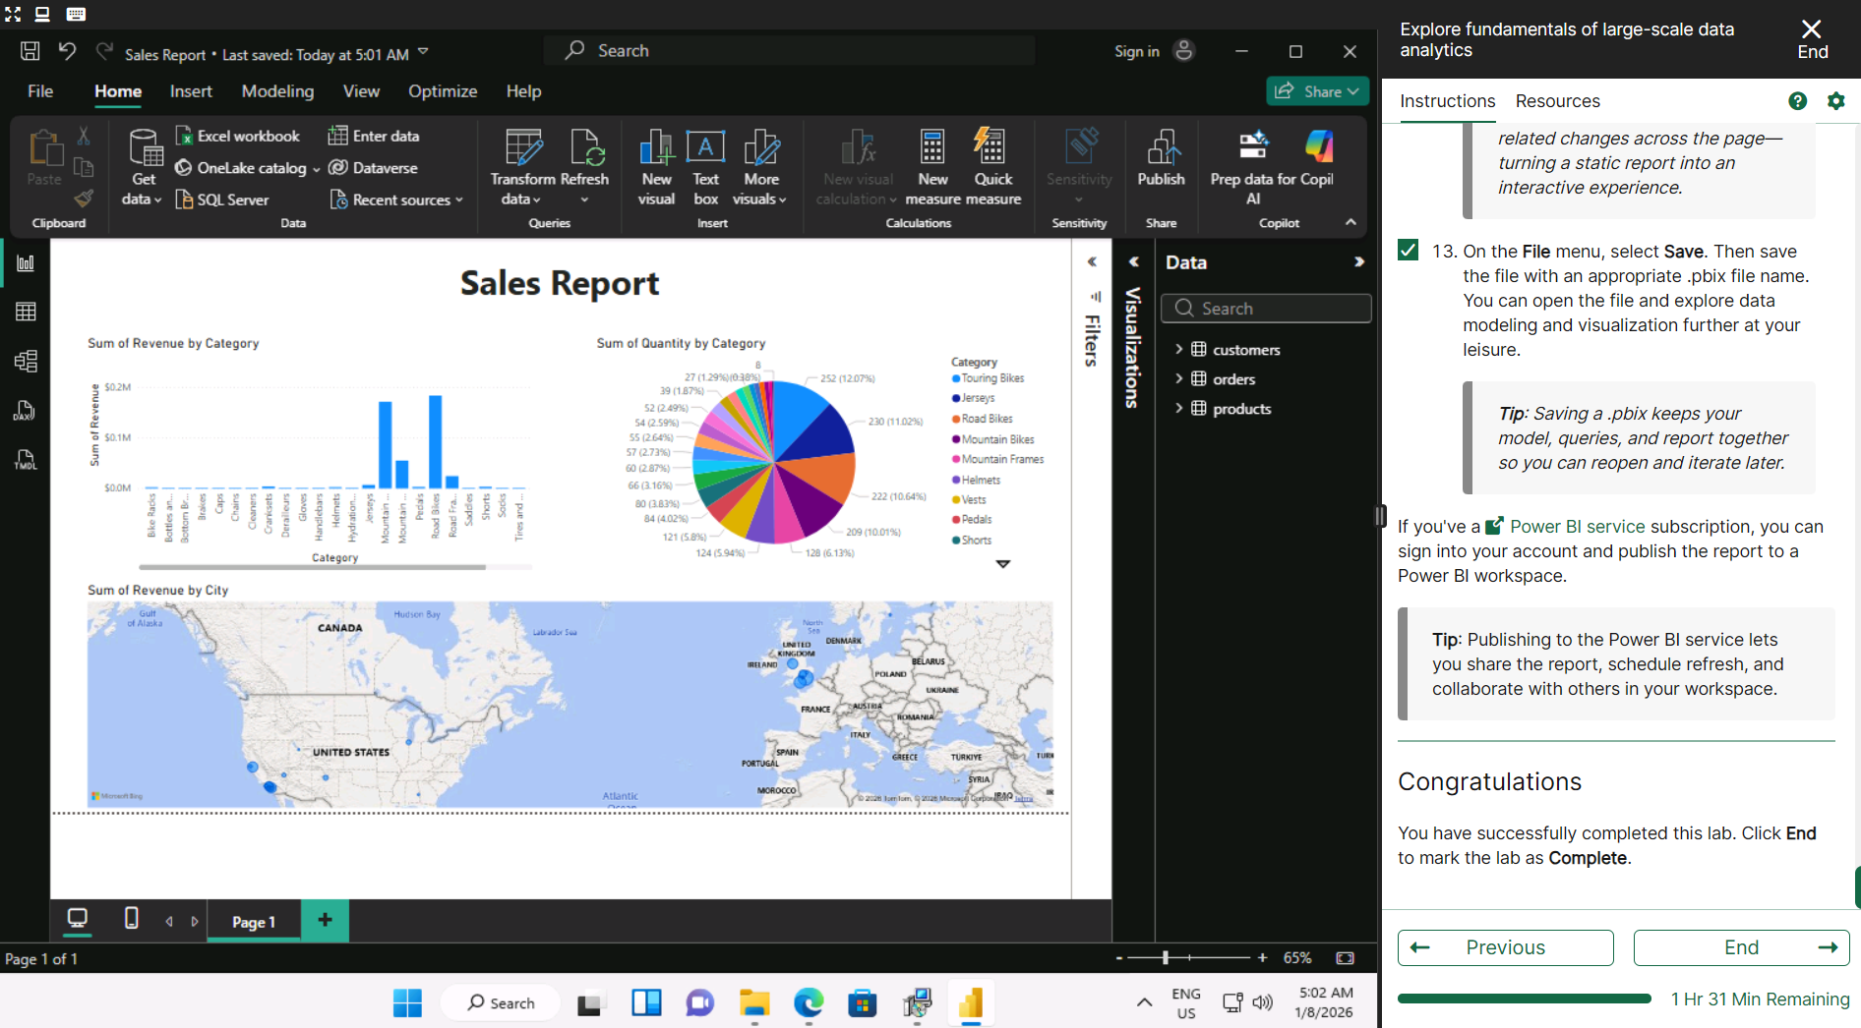

Day 4: Task 2: Skillable

In your teams, complete the Azure DP-900 practice exam and paste your result below – this is open book and please research and discuss your answers as a team.


Result | 

Day 4: Task 3 (Optional)

1. Scenario Background
"Paws & Whiskers" is a growing pet shop that aims to improve its business by analysing sales, customer information, and inventory data. Currently, the data is collected manually or stored in spreadsheets. Management is interested in transitioning to Microsoft Azure to streamline data storage, analysis, and reporting, enabling them to make data-driven decisions.

2. Data Laws and Regulations
Identify and explain the data laws and regulations relevant to handling customer data within the proposal. Ensure you cover the following points:
- GDPR Compliance: Highlight the importance of adhering to the General Data Protection Regulation (GDPR), particularly as it relates to storing and processing customer information.
- Data Protection Act (DPA) 2018: Outline how the DPA 2018 may affect the way "Paws & Whiskers" collects and stores data, ensuring compliance with UK laws on data privacy.
- Other Industry Standards: Research any additional data protection standards or regulations that may apply to pet shop data, particularly if they involve sensitive or payment information.

3. Azure Service Recommendations
Recommend Microsoft Azure services that would suit the company’s data analysis needs and explain why these services are suitable. Your recommendations should include:
- Data Storage: Identify suitable storage options, such as Azure Blob Storage or Azure SQL Database, and discuss the benefits of each for storing large datasets, including inventory, sales transactions, and customer details.
- Data Analysis Tools: Recommend tools such as Azure Machine Learning for customer behaviour analysis or Azure Synapse Analytics for analysing sales trends.
- Data Integration and Automation: Explain how services like Azure Data Factory could automate data collection and integration processes, improving efficiency.

4. Data Types and Data Modelling
Define the types of data "Paws & Whiskers" will need to work with and describe your approach to data modelling:
- Data Categories: Identify key data types, such as customer demographics, transaction history, pet inventory, and product categories.
- Data Modelling Approach: Outline how you would structure this data using a relational model or a data warehouse approach, considering factors like tables, entities, relationships, and primary keys.

5. Data Storage Formats and Structures in Azure
Discuss how you would store data within Azure and the formats you would recommend:
- Data Formats: Specify recommended formats (e.g., CSV for raw data imports, JSON for structured data, Parquet for analytics) and explain why these formats are suitable for specific data types.
- Data Security and Encryption: Include recommendations for securing data using Azure’s built-in encryption features and access controls to ensure compliance with data privacy regulations.

6. Additional Considerations
Provide any other considerations that might enhance data handling and efficiency in Azure, such as:
- Backup and Disaster Recovery: Outline a backup plan using Azure Backup or Azure Site Recovery to safeguard against data loss.
- Data Visualisation: Discuss potential use of Power BI within Azure for creating dashboards that provide management with real-time insights into sales and customer trends.
- Future Scalability: Comment on how Azure services can scale as the business grows, accommodating larger datasets and more complex analyses.

Submission Guidelines:
- Structure: Ensure your report is well-organised, with sections for each task (e.g., Data Laws, Azure Services, Data Types, etc.).
- Formatting: Include headings, bullet points where appropriate, and any visuals or diagrams that support your explanations.
- References: Cite any resources or regulations referenced in the report.
- Length: Aim for 1500-2000 words.

Course Notes

It is recommended to take notes from the course, use the space below to do so, or use the revision guide shared with the class:

Additional Information
We have included a range of additional links to further resources and information that you may find useful, these can be found within your revision guide.

END OF WORKBOOK

Please check through your work thoroughly before submitting and update the table of contents if required.

Please send your completed work booklet to your trainer.

